CS 2302

Lab 7 Report

Author: David Ayala

ID: 80617838

Instructor: Diego Aguirre

TA: Gerardo Barraza

**Introduction**

The purpose of this lab was to Implement the following dynamic-programming algorithm, Edit Distance. There isn’t much more to say other that. We had to (“Creating a separate file where you call your implementation using hard-coded strings”). And that’s it.

**Proposed Solution & Design Implementation**

So I knew how the algorithm worked so I just had to use a date structure to store the two different strings in. once that was completed I then had to go through each data structure, and compare if they are the same, while assigning values to them. I don’t think I’m explaining this very well but at this point this class has pushed to the point of being broken and I hope that I come out better for it. So once that’s done I then called it to the main file and then realized all that would give was the matrix(essentially a 2D Array). So I then had to create a different def that would return the actual value of edit distance and that’s it. I think this one works fairly well because I did it by hand and got the same answer.

**Experimental Results**

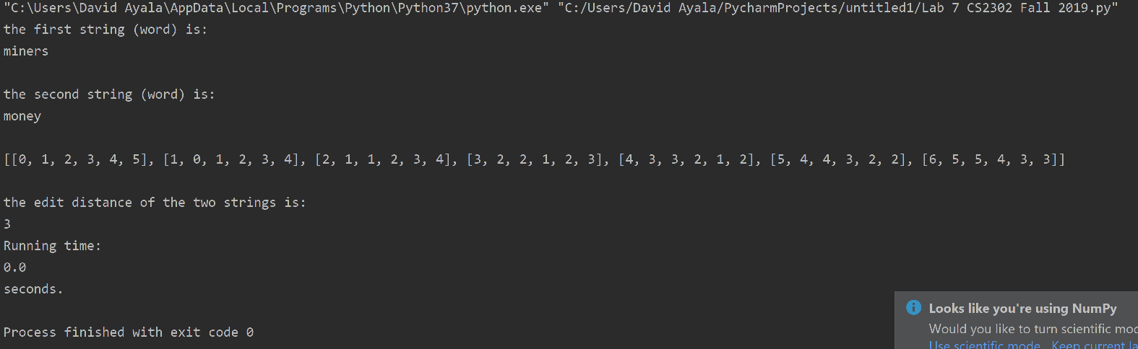

**Conclusion**

This lab allowed me to actually code edit distance algorithm if and only if it is right. It also served as practice for doing the algorithm by hand on paper and it actually helped prepare me for the exam. NO really I got this question right on the exam so that’s kind of a small win but still didn’t pass the exam so yeah.

**Appendix**

So here the code this time cause it’s not 5 different files.

import time

from EditDistance import *

str1 = 'miners'

str2 = 'money'

print('the first string (word) is:')

print(str1)

print()

print('the second string (word) is:')

print(str2)

print()

start = time.time()

EditDistance(str1, str2)

end = time.time()

print('Running time:')

print(end - start)

print('seconds.')

def EditDistance(str1, str2):

array2D = []

for i in range(len(str1) + 1):

array2D.append([-1] * (len(str2) + 1))

for i in range(len(str1) + 1):

array2D[i][0] = i

for i in range(len(str2) + 1):

array2D[0][i] = i

actualEditDistance(array2D,str1,str2)

def actualEditDistance(array2D,str1,str2):

if array2D is None:

return 'Error'

else:

for i in range(1, len(array2D)):

for j in range(1, len(array2D[i])):

if str1[i - 1] == str2[j - 1]:

array2D[i][j] = array2D[i - 1][j - 1]

else:

array2D[i][j] = min(array2D[i - 1][j], array2D[i][j - 1], array2D[i - 1][j - 1]) + 1

print(array2D)

print()

print('the edit distance of the two strings is:')

lastElementOfarray2D(array2D)

def lastElementOfarray2D(array2D):

count = 0

for eachList in array2D:

count += 1

if count == (len(array2D)):

lastElement = eachList[-1]

print(lastElement)